# SoE 2021 Marine Expert Assessments

STATE AND TREND ASSESSMENT: Water column (neritic)

Richardson AJ1,2, Everett JD1,2,3, Davies CH4, Matis, PA5, Suthers, IM3,5

1 Centre for Applications in Natural Resource Mathematics, School of Mathematics and Physics, The University of Queensland, St Lucia, QLD, 4072, Australia

2CSIRO Oceans and Atmosphere, Queensland Biosciences Precinct, St Lucia, QLD, 4067, Australia

3 School of Biological, Earth and Environmental Science, University of NSW, Sydney, NSW, 2052, Australia.

4CSIRO Oceans and Atmosphere, GPO Box 1538, Hobart, TAS, 7001, Australia

5Sydney Institute of Marine Science, Mosman, NSW, Australia

*Assessment reviewers:*

Kerrie Swadling (UTas) – [K.Swadling@utas.edu.au](mailto:K.Swadling@utas.edu.au)

**Description of species/habitat/community/process (incl. spatial area of relevance)**

The water column (pelagic) community includes microbes, phytoplankton, zooplankton, fish and other higher trophic levels including seabirds, marine reptiles and marine mammals. By definition, the pelagic community is mobile, as smaller species are moved passively by currents, and larger species often move over large distances, both horizontally and vertically. Here we focus on the neritic zone, the area close to the coast and overlying the continental shelf. We analyse the abundance/biomass of a selected group of pelagic trophic levels, those that are monitored and readily available in the neritic pelagic region from IMOS (i.e., Chlorophyll *a* representing phytoplankton biomass, Zooplankton biomass and Fish larval abundance).

**Pressures/issues of importance**

In neritic areas, the pelagic community is influenced locally by eutrophication (Uye 1994, Lin et al. 2020), but over large scales, climate change and fishing are likely to be the major pressures (Richardson & Schoeman 2004, Burgess et al. 2018). Fishing and its influence on the biomass of fish can lead to top-down cascades (Cury et al. 2000), but this is might be rare over large regions (Richardson & Schoeman 2004).

**Current state and recent trend (2016-2021) of species/ habitat/ community/ process (refer to the key to grades for state, trend provided for consistency of language)**

Based on data from the IMOS National Reference Stations (NRS), there are mixed responses of the neritic pelagic community (Fig. 1). For Chlorophyll *a*, three out of the seven NRS (Darwin, Rottnest Island and Kangaroo Island) show significant increases and the remainder show no change. For Zooplankton Biomass, three stations show significant increases (including two of the same stations – Darwin and Kangaroo Island, as does Maria Island), but there are declines at two stations (North Stradbroke Island and Port Hacking) and no change at two stations (Yongala and Rottnest Island). Fewer stations have data for fish larvae, with two showing increases (Rottnest Island and Port Hacking) and no change at three stations (North Stradbroke Island, Kangaroo Island and Maria Island). In summary, there is no evidence for a consistent decline or increase in any of these major components of the pelagic community.

**Resilience**

The base of the neritic pelagic, i.e. plankton, is more resilient to human pressures than higher trophic levels such as fish.

**Main uncertainties and knowledge gaps associated with providing an assessment of current state and recent trend**

The analysis here is based on IMOS data from only seven coastal stations, representing a very small proportion of the Australian neritic water column community. Nevertheless, the variables in this dataset have all been collectively, and consistently, sampled at the same time and location throughout. There are also limited fishery-independent estimates of fish biomass in Australian waters, so we have used data on fish larvae from IMOS. It was also beyond our time constraints to summarise all available information on fish catch (which is a relatively poor abundance of biomass because of management and selectivity biases), seabirds, sea turtles and whales. We have thus analysed only select components of the pelagic community.

**Pressures/issues of importance and associated management**

There is scope for management interventions in some areas and some components of the neritic pelagic community. For example, for higher trophic levels, management interventions can ensure sustainable fisheries management practices. And for semi-enclosed coastal areas, eutrophication can be managed to reduce impacts on phytoplankton (here we used Chlorophyll *a* as a proxy) and zooplankton. However, the main driver of large-scale changes in the neritic water column community is climate change.

**Outlook**

Continued monitoring of the neritic water column community will enable the future identification of both abrupt and long-term changes. Once IMOS time series are >20 years long, we will be more confident in distinguishing long-term trends from short-term variability in the pelagic community (Poloczanska et al. 2013, Hoegh-Guldberg et al. 2014).

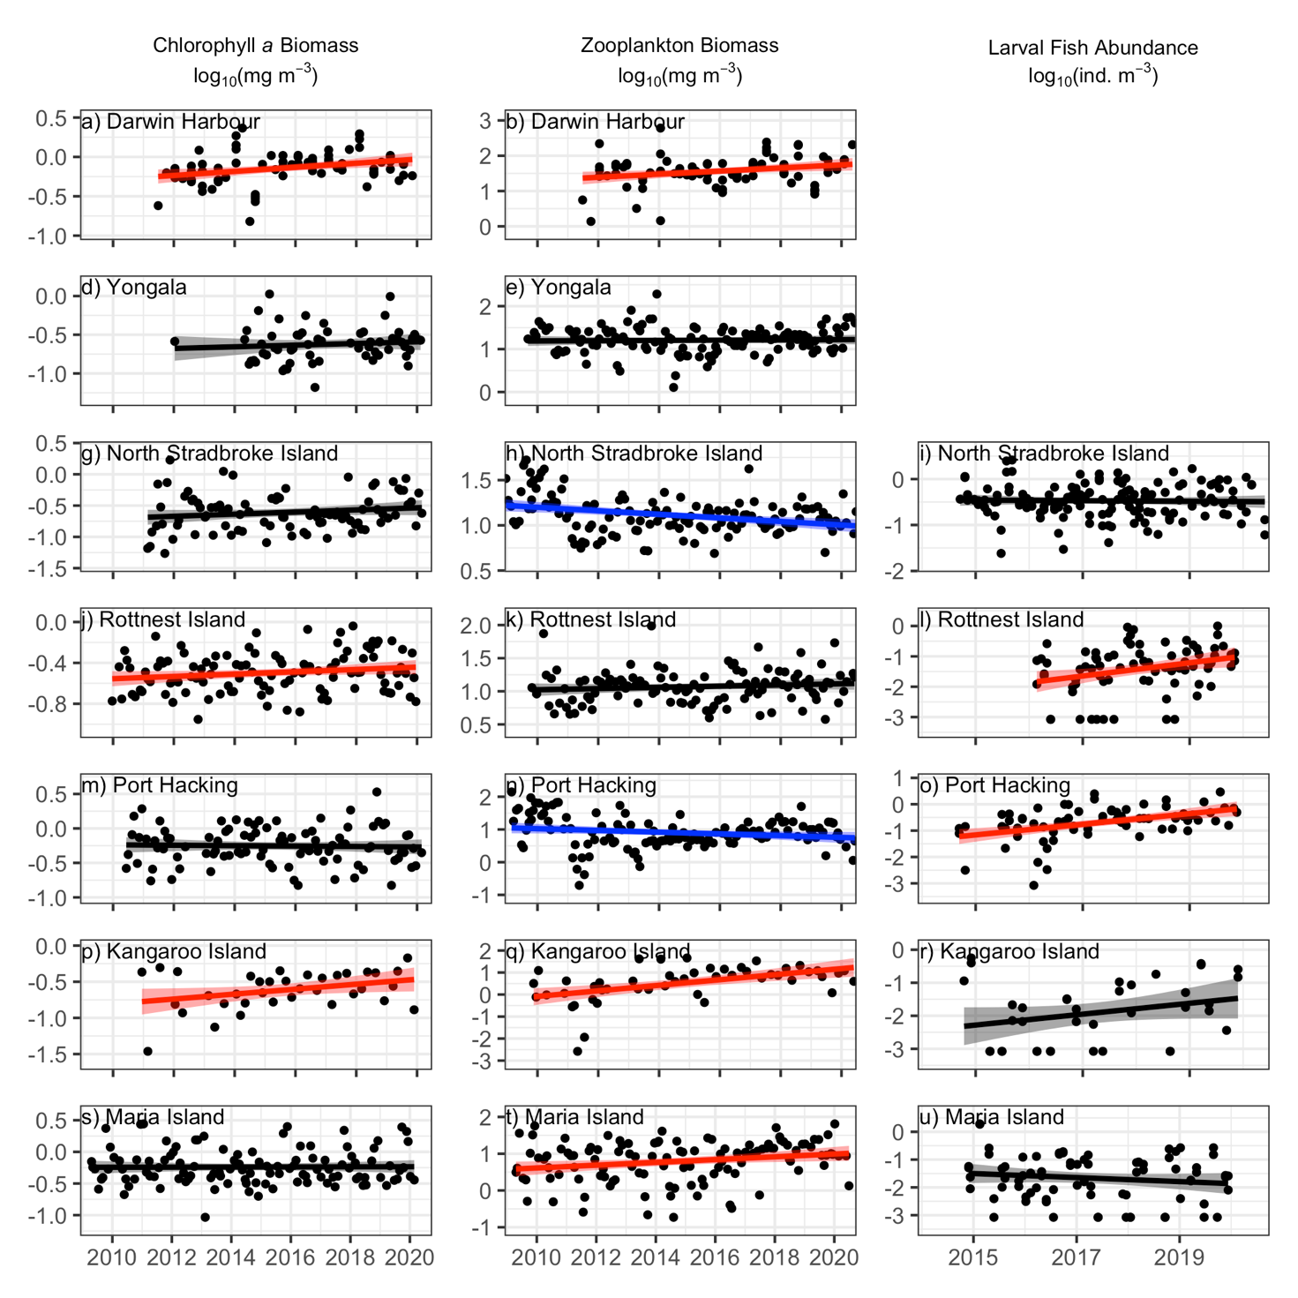

**Figure 1.** Data from theIMOS National Reference Stations showing: (left) concentration of Chlorophyll *a*; (middle) Zooplankton biomass; and (right) Fish larval abundance. Black dots represent data points and the line (and shading) represent the linear regression (and confidence intervals) of the data after the seasonal cycle has been removed. Colours show the direction and significance of the trend: Blue: significantly decreasing, Red: significantly increasing, Black: no significant trend.

*Assessment summary*

|  |  |  |  |  |  |
| --- | --- | --- | --- | --- | --- |
| Year | Assessment grade | | Confidence | | Comparability with 2016 assessment |
| Grade | Trend | Grade | Trend |
| 2021 | Good | Stable | Limited | Limited | NA |
| 2016 | NA | NA | NA | NA | NA |

**Summary text:** We analysed a limited representation (phytoplankton, zooplankton and fish larvae) of the neritic water column community based on IMOS data. There was no consistent trend among locations and trophic levels.

**State and trend of bioregion relative to the national assessment:**

*North:* Similar to the national assessment

*North-east:* Similar to the national assessment

*Temperate-east:* Similar to the national assessment

*South-east:* Similar to the national assessment

*South-west:* Similar to the national assessment

*North-west: NA*

**References**

Burgess, M.G., McDermott, G.R., Owashi, B., Reeves, L.E.P., Clavelle, T., Ovando, D., Wallace, B.P., Lewison, R.L., Gaines, S.D., Costello, C., 2018. Protecting marine mammals, turtles, and birds by rebuilding global fisheries. Science 359, 1255–1258.

Cury, P., Bakun, A., Crawford, R.J.M., Jarre, A., Quiñones, R.A., Shannon, L.J., Verheye, H.M., 2000. Small pelagics in upwelling systems: patterns of interaction and structural changes in “wasp-waist” ecosystems. *ICES J Mar Sci* 57, 603–618.

Davies, C. and Sommerville, E. (Eds.) (2020), National Reference Stations Biogeochemical Operations Manual Version 3.3.1. Integrated Marine Observing System. DOI: 10.26198/5c4a56f2a8ae3 (<http://dx.doi.org/10.26198/5c4a56f2a8ae3>).

Hoegh-Guldberg O, Cai R, Poloczanska ES, Brewer PG, Sundby S, Hilmi K, Fabry VJ, Jung S, and 21 Contributing authors including Richardson AJ (2014) Chapter 30: The Ocean. In: *Climate Change 2014: Impacts, Adaptation, and Vulnerability. Part B: Regional Aspects.* *Contribution of Working Group II to the Fifth Assessment Report of the Intergovernmental Panel on Climate Change* [Barros VR, Field CB, Dokken DJ, Mastrandrea MD, Mach KJ, Bilir TE, Chatterjee M, Ebi KL, Estrada YO, Genova RC, Girma B, Kissel ES, Levy AN, MacCracken S, Mastrandrea PR, White LL (Eds)]. Cambridge University Press, Cambridge, United Kingdom and New York, NY, USA, pp. 1655-1731.

Lin, G., Li, K., Liang, S., Li, Y., Su, Y., Wang, X., 2020. Compound eutrophication index: An integrated approach for assessing ecological risk and identifying the critical element controlling harmful algal blooms in coastal seas. Marine Pollution Bulletin 150, 110585.

Poloczanska ES, Brown CJ, Sydeman WJ, Kiessling W, Moore PJ, Brander K, Bruno JF, Buckley L, Burrows MT, Duarte CM, Halpern BS, Holding J, Kappel CV, O’Connor MI, Pandolfi JM, Parmesan C, Schoeman DS, Schwing F, Thompson SA, Richardson AJ (2013) Global imprint of climate change on marine life. *Nature Climate Change* 3: 919-925. *DOI 10.1038/NCLIMATE1958.* 7 pp.

Richardson AJ, Schoeman DS (2004) Climate impact on plankton ecosystems in the Northeast Atlantic. *Science* 305: 1609-1612.

Schminke HK (2006) Entomology for the copepodologist. *Journal of Plankton Research* **29**, 149-162.

Uye S-I. 1994. Replacement of large copepods by small ones with eutrophication of embayments; cause and consequence. *Hydrobiologia*. 292-293(0): 513-519.

*Metadata*

Please include details of:

1. Data used in the assessment (incl. spatial and temporal coverage)

We analysed Chlorophyll a, Zooplankton biomass and Fish larval data from the IMOS National Reference Stations, see Eriksen et al. (2019) for detailed methodology for Zooplankton, Davies & Sommerville (2020) for Chlorophyll a and larval fish methodologies).

1. Quality of data used in the assessment

IMOS data used in this assessment are the only time series information available in Australia suitable for this analysis. Before the introduction of IMOS, this assessment would not have been possible. Collecting and counting zooplankton data in IMOS adheres to strict quality control protocols (Eriksen et al. 2019). All data are collected under Ocean Best Practices, the BGC manual is published in Frontiers OBP repository (Davies & Sommerville 2020), <https://repository.oceanbestpractices.org/handle/11329/1490>.

1. Custodian and location of data

Chlorophyll *a*, Zooplankton and Fish larval data were processed by the IMOS National Reference Station facility. All data are freely available from the AODN (<https://portal.aodn.org.au/>).

1. Method used to determine state or recent trend

For Chlorophyll *a*, Zooplankton and Fish larvae, abundance or biomass data were used as response variables in linear models, with Year and Month (to adjust for seasonality and reduce temporal autocorrelation) as predictors. The trend line in each figure is the slope of the Year term. Following visual assessment of the diagnostic plots of the model, we log10-transformed zooplankton abundance to reduce leverage of outliers and to improve the homogeneity of variance assumption.

1. If the assessment has changed from the 2016 assessment what factors/parameters have contributed to the change and how?

NA

Relevant publications (particularly those published since the 2016 assessment) and links to publications

**Support for zooplankton state and trends observed**

Richardson AJ, Eriksen R, Moltmann T, Hodgson-Johnston I, Wallis JR (2020) State and Trends of Australia’s Ocean Report, Integrated Marine Observing System, Hobart. 164 pp. A total of 27 contributions from 70 authors from 12 institutions. <https://www.imosoceanreport.org.au/>